Instructions for submitting information claimed as not subject to disclosure to the public in the GEOS Air Branch Application System

ALERT: ALL INFORMATION SUBMITTED USING GEOS IS OPEN AND AVAILABLE TO THE PUBLIC.

Information that a person claims is not subject to disclosure to the public (“Non-disclosure Claims”) MUST be submitted to EPD in compliance with EPD’s Procedures for Submitting Information Pursuant to a Claim that Information in the Submittal is Protected Under Georgia Law from Disclosure to the Public.

Detailed instructions can be found via the link on the GEOS login page.
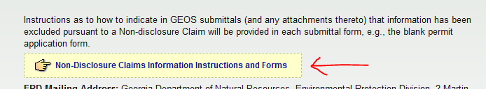

Procedures, Forms and Instructions:
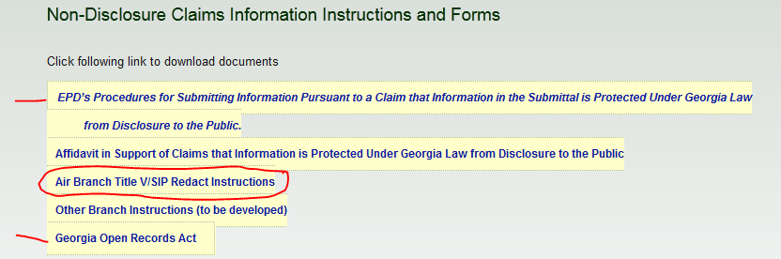

If an Applicant/preparer determines that there is a need to include information not subject to disclosure in the electronic GEOS application, do the following:

- Checkmark the box stating that “This application includes Information the Applicant Claims is Protected Under Georgia Law from Disclosure to the Public:”

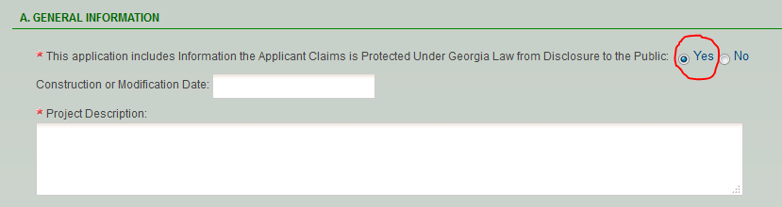

- Instead of entering the Protected piece of information, the phrase [REDACT###] should be used in the entry field.
  - ### should be incremented by the Preparer for each subsequent piece of information that is “not subject to disclosure…”
  - Remember that only items marked * are required to be submitted (if it isn’t a required field and it isn’t necessary for permitting purposes then don’t include it).
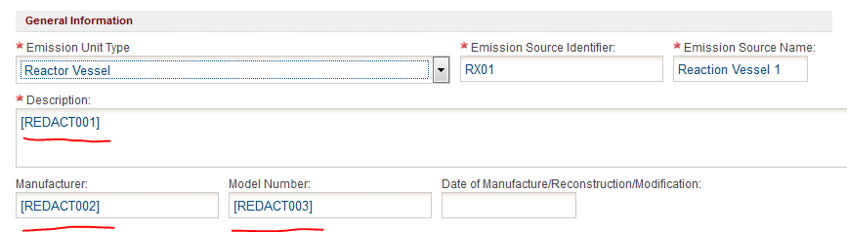

- With the application complete, and all redacted fields labeled as in Step 2, use GEOS to generate and download a “Redact Report” listing the items tagged as [REDACTXXX] in the Attachment section.

  - This report will only be able to be submitted by Mail! Do not attach electronic copy!

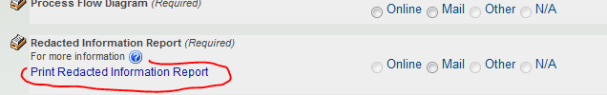

  - Hover over for additional instructions.

- Populate the “Redact Report” with the claimed protected information or cite an Attachment on the “Redact Report” and MAIL it to the Division in Paper form according to the EPD’s Procedures for Submitting Information Pursuant to a Claim that Information in the Submittal is Protected Under Georgia Law from Disclosure to the Public.

  - The Redacted Report can be downloaded and filled out and then PRINTED.
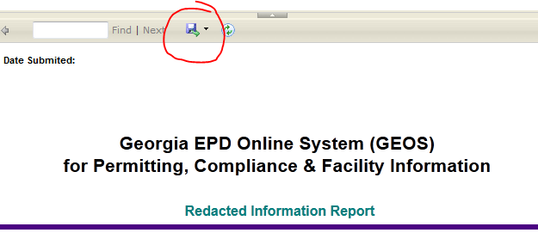

  - The Affidavit in Support of Claim[s] that Information is Protected under Georgia Law from Disclosure to the Public should be PRINTED.
  - The entire Public version of the application should be PRINTED. This can only be done AFTER it has been submitted. Open each form view in pdf and print.
  - Do not include electronic versions of the Redact Report or any Privileged Information in the uploaded Attachments.

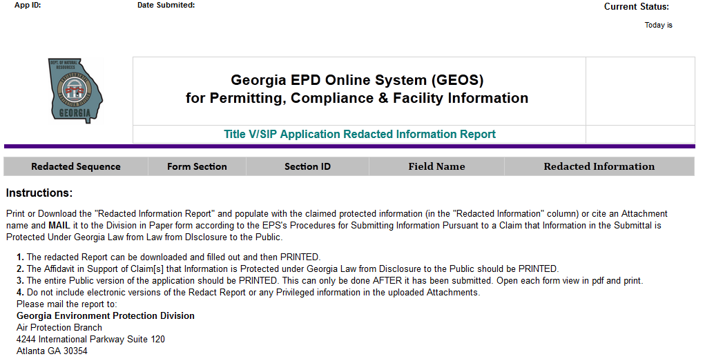

- Once the GEOS application has been completed , and the protection information identified in the redact report, the Applicant will must complete and have notarized the Affidavit in Support of Claim[s] that Information is Protected under Georgia Law from Disclosure to the Public and include a scan of this affidavit as an Attachment in the electronic application.

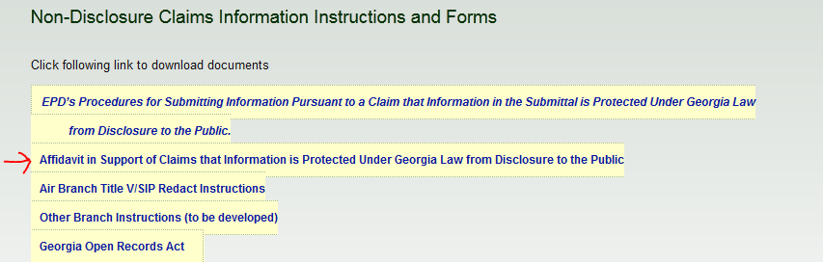

- Once the Redact Report, paper version of the public application and Affidavit are received by the Division the information will be reviewed to make sure it meets the definitions listed above and the application submittal will be marked complete by the assigned EPD staff member.

If an Applicant only has attachments that they claim should be protected under Georgia Law from Disclosure to the Public the Applicant should do the following:

- Checkmark the box stating that “Information not subject to disclosure under the Georgia…” is included in the application.

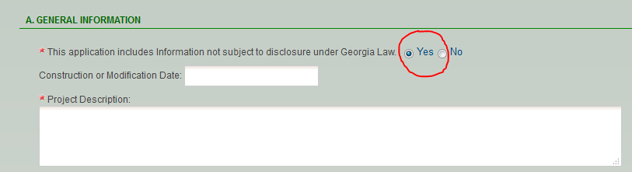

- Do not enter any [REDACTXXX] fields.
- Follow Steps 3 and on above.

ALERT: GEOS SUBMITTALS EXCLUDING INFORMATION PURSUANT TO NON-DISCLOSURE CLAIMS ARE NOT COMPLETE UNTIL EPD RECEIVES THE EXCLUDED INFORMATION SUBMITTED IN COMPLIANCE WITH EPD’s PROCEDURES.

GEOS submittals (and/or any attachments thereto) from which information has been excluded pursuant to a claim that the excluded information is not subject to disclosure to the public (“Non-disclosure Claims”) are NOT complete until EPD receives the excluded information submitted in compliance with EPD’s Procedures for Submitting Information Pursuant to a Claim that Information in the Submittal is Protected Under Georgia Law from Disclosure to the Public.

